PC Security

Robert Gabriel

Lab 2

Task 1: Patching your OS: Write a paragraph on the importance of patching your computer systems. This should include your OS, browser and end-user applications.

Plainly put, software updates whether big or small are important, updates are necessary. Computers and the software they house require regular updates to insure they go forward to operate safely and efficiently. Updates add value to Microsoft Windows, your antivirus and the drivers that keep your computer working. Programmers are interested in keeping their software up to date and fully functional, which is an opportunity you should take. Why not take advantage of new features when they’re made available to help improve your system.

As said above viruses are ever-evolving, which too means you’re running system, antivirus and other applications (like web browsers) should continuously develop as well. Everyone ignores system updates for a bit of time but this makes your computer more of threat to new viruses.

Updates serve a number of functions. Examples are below:

* Fix security holes
* Optimize the utilization of resources on the operating system
* Add newer and more secure features
* Remove old and unprotected features
* Update drivers to increase software efficiency
* How new browser versions benefit you and your company:
* Increased security benefits
* Avoid compatibility problems associated with older versions
* Allow your applications to work more smoothly and efficiently
* Allow access to the newest applications
* Many new websites function only in newer browser versions

Web browser’s patches and updates serve a very great deed, keeping the base user safe fand there computer from online attacks. Keeping your software updated to the most recent version could save your computer and your personal information from getting in the hands of hackers.

Task 2: Automatic updates, Show how you would check for updates. Show how you would set up Automatic Updates.

# C:\Users\r00102430\Desktop\check for updates\1.PNGCheck for updates.

1. Click on the Start button. In the lookup box, type Update, and then, in the list of results, click Windows Update.
2. 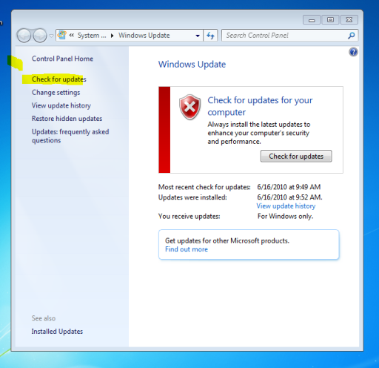In the left panel on the left side, click Check for updates.
3. Windows will look for the latest updates for your computer at are avabile online.

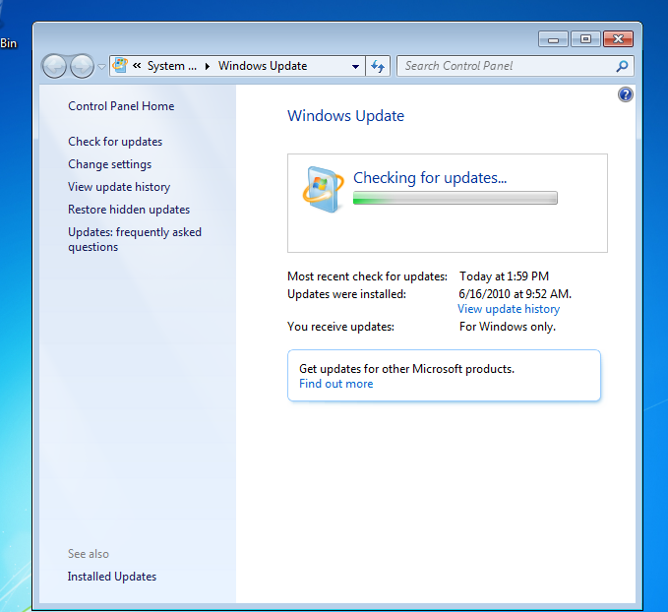

# To enable Automatic Updates

1. Click the Start button in the taskbar
2. Search for windows update
3. On the left panel, click change settings.
4. Select your automatic update automatically (recommended)
5. Click Apply and then click OK to accept the changes and close the window.



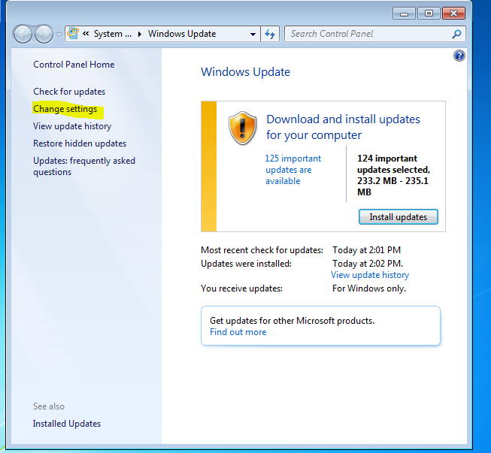

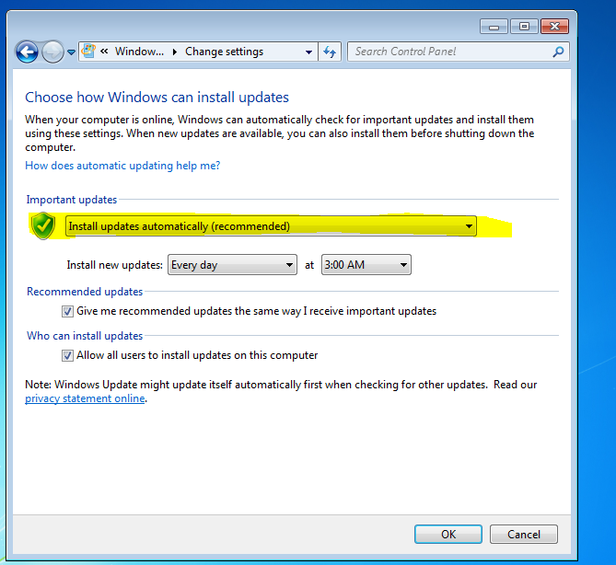

Task 3: Microsoft Baseline Security Analyser (15 marks)

# What is MBSA used for?

MBSA stands for Microsoft Baseline Security Analyser. It is a software tool built by Microsoft to help determine the security state of a user’s computer. It checks and gets it rating by assessing missing security updates and less-secure security settings within Microsoft Windows, Windows components such as Internet Explorer and all other Microsoft products on the machine.

Download, Install and run MBSA against your machine and discuss the results.

Discuss some of the items scanned for in the Windows check portion of the scan.

## Set up and details.

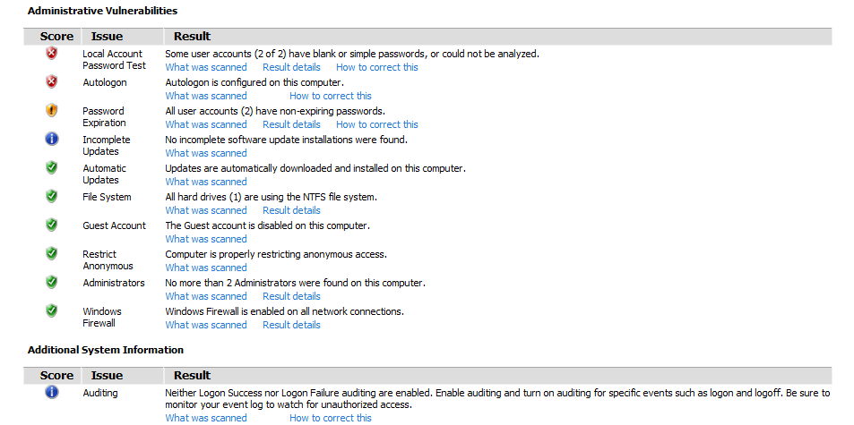After I downloaded and install MBSA, onto my computer and ran it for the first time. It asked me did I want to scan the computer or a network.

I clicked on just the one machine (as I was using a virtual machine). Next it asked me what I wanted to scan; the options can be seen on the picture on the right. I did a full scan with all options, it searched for poor passwords, administrative vulnerabilities, along with other sercity.

The search itself took about 20 minutes for it to complete. The results can be seen, let it be noted, there was a few updates waiting to be installed along with that I was using a virtual machine.

The major notices were that there were 80 updates waiting to be installed along with 3 service packs. Showing the computer isn’t up to date. This can be fixed using the windows update featured earlier in this report. The other failure it spotted was due to the virtual machine.

## Note

Some of the other failures where due to the fact of how the virtual machine is set up. This is the auto login, having no passwords on the accounts. I would include these as false positives.

# Windows check portion of the scan.

The windows check portion checks if current configuration makes your machine vulnerable to easy attack. These things include weak passwords, Automatic Updates not turned on, Firewall not turned on, or applications that are in need of update.

In the windows check portion of the scan it checked the following areas

* The file systems
* Administrative Vulenarbityes.
* The windows firewall system.

Some notes to take away:

* This computer was all passed beside the areas below. Mostly cause of the virtual machine.
* It saw that auto download and install of updates was turned on.
* There were updates avable.
* This is where it came across the problems with the login and the virtual machine.
* It noted that there were some uncompleted updates on the machine.
* Note in the patches the internet explorer is updated to version 10 , Helping against attacks though the web and hardening the os.



# Task 4: (10 marks)

# Show how to use the Windows 7 built in Backup and Restore utility, including setting up scheduled Backups.

### You can backup up a small folder to demonstrate. To back up your files

1. Open Backup and Restore by clicking the **Start** button.
2. Click **Control Panel**,
3. Click **Backup and Restore**.
4. Do one of the following:
   * If you've never used Windows Backup before, click **Set up backup**, and then follow the steps in the wizard. Administrator permission required If you're prompted for an administrator password or confirmation, type the password or provide confirmation.

Backups help ensure that your files aren't permanently lost or damaged. With automatic backups, you don't have to remember to back up your files. You can change your automatic backup settings (such as how often you back up, the type of storage you use or the types of files you back up) whenever you want.

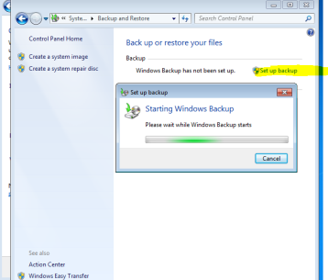

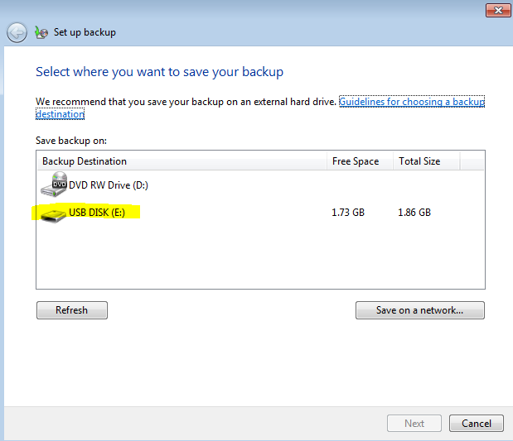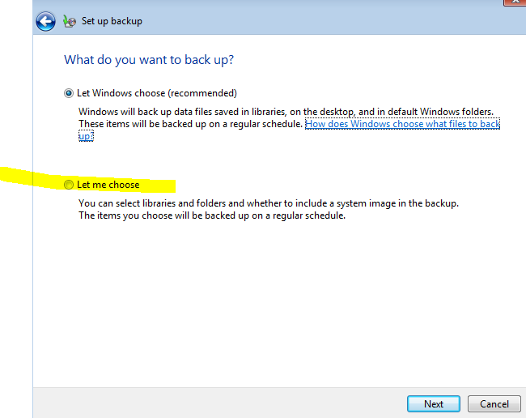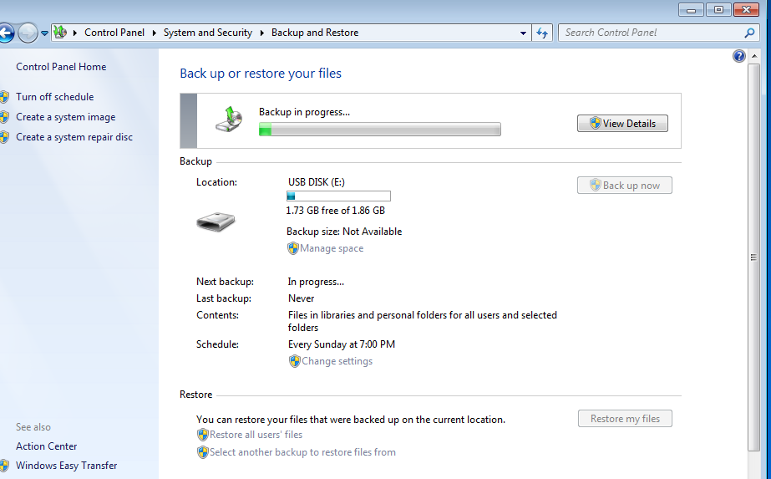

# To set up automatic backups

If you've never used Windows Backup before, the Windows Backup wizard automatically creates a schedule for you, which you can change.

1. Open Backup and Restore by clicking the **Start** button ,
2. Click **Control Panel**
3. Click **Backup and Restore**.
4. Click **Set up backup**
5. Click next and click change schedule
6. Click perform auto backups.

